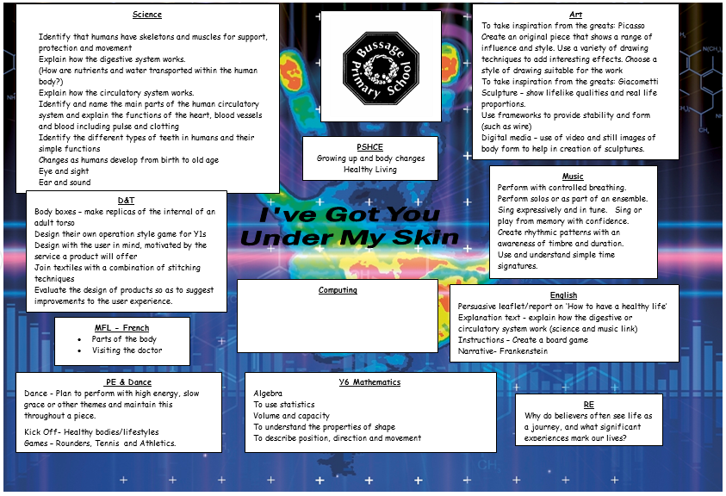

Computing

Understand networks including the internet

Use and combine a variety of different software

Design, write and debug programs

Support my friends to protect themselves and make good choices online

Explain the consequences to myself and others of not communicating kindly and respectfully.

Explain the consequences of sharing too much about myself online

Missing angles Arithmetic

Finding the mean average